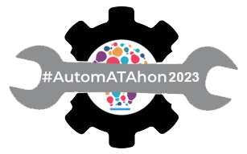
Template for AutomATAhon2023 Team #ATAGTR2023

Team Name:
Organization Name:
Short Description of Team (Team tag line):
Note - Maximum 4 members are allowed in a team, minimum 1 member can be there in a team. Kindly fill in all the relevant details of all the team members.
In case of any queries, kindly reach out to: ATASupport@agiletestingalliance.org

Team member 1
- Name:
- Photo (please add photo in this document itself):
- Organization:
- LinkedIn Id:
- Whatsapp Number:
- Email Address:
- Summary Profile (short not more than 100 words):
------------------------------------------

Team member 2 (If Applicable)
- Name:
- Photo (please add photo in this document itself):
- Organization:
- LinkedIn Id:
- Whatsapp Number:
- Email Address:
- Summary Profile (short not more than 100 words):
------------------------------------------

Team member 3 (If Applicable)
- Name:
- Photo (please add photo in this document itself):
- Organization:
- LinkedIn Id:
- Whatsapp Number:
- Email Address:
- Summary Profile (short not more than 100 words):
------------------------------------------

Team member 4 (If Applicable)
- Name:
- Photo (please add photo in this document itself):
- Organization:
- LinkedIn Id:
- Whatsapp Number:
- Email Address:
- Summary Profile (short not more than 100 words):
------------------------------------------

Rules of AutomATAhon 2023: https://gtr.agiletestingalliance.org/automatahon/
Undertaking:
I / We <name(s)> have read all the rules of AutomATAhon and understood them fully, and I / We will abide by them fully.
Date:
Place:

